**LEBANESE AMERICAN UNIVERSITY**

**USAID – HIGHER EDUCATION SCHOLARSHIP PROGRAM**

**HES - Volunteering Program Verification Form**

This form is to be used to document volunteering hours. If a student volunteers for multiple organizations, a separate form must be used for each organization. **This form must be turned in by the 28th of each month, the latest.**

I certify that the scholar Sara Walid Azzam completed a total of 5 hours of service at InnovaThrive.

The hours were completed hours as per the below:

Hours # 5 (date) _2/12 – 6/12_ (initials of supervisor) __A.K.___

Hours # 0 (date) _9/12 – 13/12_ (initials of supervisor) __A.K.___

Hours # 0 date) _16/12 – 20/12 (initials of supervisor) __A.K.___

Hours # 0 date) _23/12 - 27/12 (initials of supervisor) __A.K.___

Brief description of the activities the scholar performed or participated in:

Research: The Role of User-Generated Content in Marketing Strategies  
In my field of Business Information Technology Management, I conducted research on the impact and role of user-generated content (UGC) in modern marketing strategies. The study explored how businesses leverage content created by customers, such as reviews, social media posts, and testimonials, to enhance brand visibility, build trust, and drive consumer engagement.  
  
Key areas included analyzing the effectiveness of UGC in creating authentic connections with audiences and its role in cost-efficient marketing campaigns. I also examined challenges, such as managing negative feedback and ensuring content aligns with brand values. Finally, the research highlighted the potential for integrating UGC with emerging technologies like AI and data analytics to refine targeting and maximize its strategic impact.

Written feedback about the scholar’s performance:

Sara’s research on user-generated content (UGC) in marketing was impactful. She explored how UGC enhances brand visibility and engagement, while highlighting challenges like managing negative feedback and aligning with brand values.

Please rate the overall performance of the scholar at your organization:

|  |  |  |  |
| --- | --- | --- | --- |
|  | Mastery (5) | Proficient (3) | Emerging (1) |
| **Problem solver** | X |  |  |
| **Engaged & Committed** | X |  |  |
| **Open-minded & multicultural** | X |  |  |

Signature

& stamp

__________________________

_

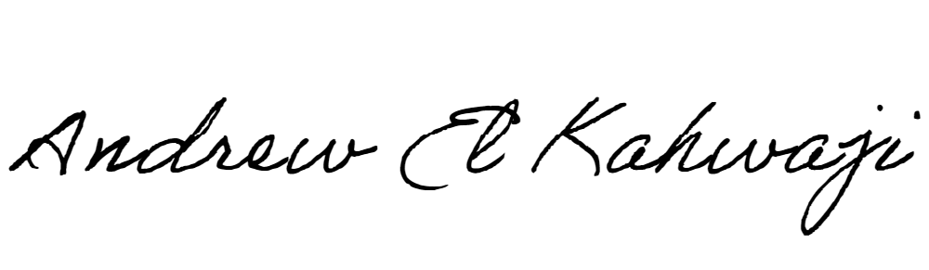

Printed Name _Andrew El Kahwaji_

Date __26/12/2024___

Email __andrew.lifesculptor.coo@gmail.com __

Phone __+961 71 914 378__